Using Outlook for a Semester Weekly Schedule
ENGR Academic Coaching

First, add all semester core commitments to Outlook Calendar “weekly” view.
- Sign-In: Open the Outlook app and sign-in with your UARK email.
- Import Class Schedule: Use UA Connect to import your semester schedule into Outlook.
  - See instructions on the next page for importing your class schedule.
- Add Events: Add other core commitments to your weekly schedule.
  - Daily lunch breaks, work, gym, plans with friends, commute time, etc.
  - Use “New Appointment” to add blocks of time to your calendar for events.
  - Distinguish: Always include a title, location, and time.
  - New Color: Use “Categorize” to color code core commitments as a new category.
  - Use “Make Reoccurring” option to create repeating events.
Second, add all demands for the semester into Outlook “weekly” view.
- Identify: Locate all coursework due dates in the syllabus and/or Blackboard for all classes.
- This includes all exams, quizzes, homework, projects, finals, etc. for the full semester.
- Add Demands: One class at a time, add all course demands to your weekly view.
  - Use “New Appointment” and create 30-minute reminder blocks.
  - Distinguish: Title the event (e.g., GNEG – Exam 3). Color code a new category for demands.
Third, plan when you will meet all your demands (time allocation).
- When to Plan: Choose one weekly time to review your demands (e.g., Sundays after lunch) and allocate when you will meet all your deadlines (when you will do homework, study, etc.).
- Add this block to your weekly calendar and make the event repeat every week.
- Allocate Times: Block the times you will be using to meet each of demand (completing homework 2, studying for exam 3, etc.). Always allocate time for two weeks out minimum.
  - Optional: Some students may prefer to use a physical planner to allocate when they will meet demands while using Outlook Calendar online to see all deadlines.
Lastly, keep your calendar updated.
- Life happens! Assignments will be moved, classes cancelled, we may be out sick, etc. This tool only works if we keep your calendar updated and remain consistent.
- Tip: Download the Outlook app on your phone to use your calendar anywhere. Select the “3 Day” view option to see your weekly calendar.

How to Import Your Semester Class Schedule into Outlook Calendar
- Confirm you are signed-in to the Outlook app with your UARK email, not the online version.
- Log-in to UA Connect > Manage Classes > Enroll.
- Select the “My Class Schedule" option.
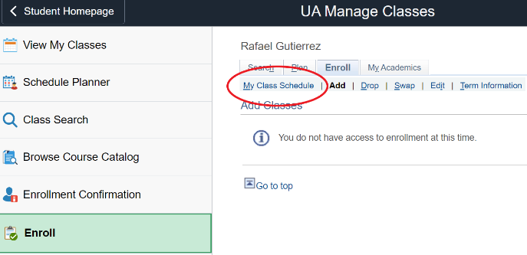
- Scroll to the bottom of your class list and select “Add to Calendar” to download as a file.
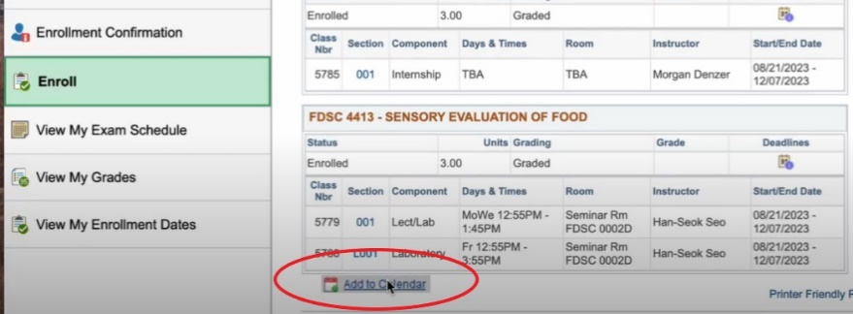
- Go to the file. Right click > “Open With” > Microsoft Outlook.
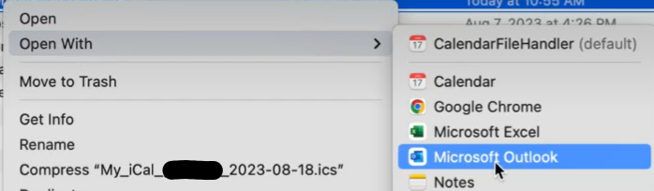
- The “Add Event” window from Outlook will open to add all your class times as events. Select “Import”, then “Done”. Check your Outlook weekly calendar to confirm your classes have been imported.
